 

**COLLEGE CODE :**3105

**COLLEGE NAME :**Dhanalakshmi Srinivasan College of Engineering and Technology

**DEPARTMENT :**B.Tech Information Technology

**STUDENT NM-ID:** 0b5a5ab926cf3bd8da64e05f4db69ddd

**ROLL NO :**310523205022

**DATE :**07/05/2025

**Completed the project named as**

**TECHNOLOGY-SUPPLY CHAIN MANAGEMENT**

**SUBMITTED BY,**

**NAME : Dhanalakshmi**

**MOBILE NO: 6374225562**

## **Phase 4: Performance of the Project**

**Title: AI-Powered Supply Chain Management System**  
 **Objective:**  
 The focus of Phase 4 is to enhance the performance of the AI-powered supply chain management system by refining its predictive and optimization models, increasing system scalability, and improving its ability to handle a growing volume of suppliers, logistics data, and customer orders. This phase will also improve real-time IoT tracking, streamline communication across the supply chain, and reinforce data security protocols to ensure compliance and trust at scale.

### **1. AI Model Performance Enhancement**

**Overview:**  
 AI-driven demand forecasting, inventory optimization, and route planning models will be refined using historical data, real-time inputs, and performance feedback from earlier phases.

**Performance Improvements:**

* **Accuracy Testing:** The AI models will be retrained with broader datasets incorporating seasonal demand variations, supplier delays, and logistics disruptions.
* **Model Optimization:** Techniques such as hyperparameter tuning, ensemble learning, and model pruning will improve both prediction accuracy and computational efficiency.

**Outcome:**  
 The system will deliver highly accurate demand forecasts and supply chain optimizations, reducing overstock, stockouts, and delivery delays while improving cost efficiency.

### **2. Workflow & Chatbot Performance Optimization**

**Overview:**  
 The chatbot and automation interfaces used by procurement officers, warehouse staff, and suppliers will be optimized for faster response times, better contextual understanding, and multilingual support planning.

**Key Enhancements:**

* **Response Time:** System latency will be minimized, even under peak usage (e.g., during procurement cycles or seasonal demand spikes).
* **Language Processing:** Natural language understanding will be refined to handle industry-specific terminology and regional dialects, with multilingual readiness.

**Outcome:**  
 Supply chain personnel will experience faster, more intuitive interactions with the system, leading to quicker decision-making and reduced bottlenecks in communication.

### **3. IoT Integration Performance**

**Overview:**  
 Integration with IoT devices (e.g., GPS trackers, smart sensors, RFID) will be optimized to ensure real-time tracking of goods, temperature monitoring, and automated inventory updates.

**Key Enhancements:**

* **Real-Time Data Processing:** System enhancements will reduce latency in receiving and processing IoT data from transport vehicles and warehouses.
* **Improved API Connections:** API calls to logistics partners and IoT platforms will be fine-tuned for seamless data exchange and enhanced monitoring.

**Outcome:**  
 Real-time visibility across the supply chain will improve, enabling proactive responses to delays, damage, or theft, and increasing overall operational transparency.

### **4. Data Security and Privacy Performance**

**Overview:**  
 As the system scales, security measures will be intensified to protect sensitive business data, supplier contracts, and shipment details from unauthorized access and breaches.

**Key Enhancements:**

* **Advanced Encryption:** Updated encryption protocols (e.g., TLS 1.3, end-to-end encryption) will be implemented across data flows and storage.
* **Security Testing:** Penetration tests, compliance audits, and vulnerability assessments will ensure the system meets global data security standards (e.g., ISO 27001, GDPR, SOC 2).

**Outcome:**  
 Supply chain data will remain secure and compliant, even as the system handles increased traffic and third-party integrations.

### **5. Performance Testing and Metrics Collection**

**Overview:**  
 Thorough testing will validate the system’s ability to handle increased supplier, customer, and logistics interactions. Performance data will guide final tuning before deployment.

**Implementation:**

* **Load Testing:** High-volume transaction simulations will evaluate system behavior under heavy demand scenarios (e.g., peak shopping seasons).
* **Performance Metrics:** System throughput, decision latency, success/failure rates of operations, and user satisfaction scores will be recorded.
* **Feedback Loop:** Input from supply chain operators and managers will be used to fine-tune user experience and system features.

**Outcome:**  
 The system will demonstrate resilience, scalability, and readiness for full-scale deployment in complex, multi-tiered supply chain environments.

### **Key Challenges in Phase 4**

1. **Scaling to Global Operations:**
   1. **Challenge:** Adapting the system to manage a wider range of suppliers, geographies, and logistics requirements.
   2. **Solution:** Distributed computing, optimized AI models, and scalable architecture will ensure high performance across regions.
2. **Maintaining Real-Time Insights:**
   1. **Challenge:** Ensuring timely data collection from IoT devices and external systems.
   2. **Solution:** Robust edge computing and fault-tolerant data pipelines will reduce lag and ensure data integrity.
3. **Data Security at Scale:**
   1. **Challenge:** Protecting sensitive supply chain data across multiple partners and jurisdictions.
   2. **Solution:** Multi-layered security and strict access control policies will be enforced.

### **Outcomes of Phase 4**

1. **Improved Forecasting & Optimization:**  
    AI models will generate more reliable forecasts and logistics plans, reducing operational costs and improving service levels.
2. **Enhanced Communication Efficiency:**  
    Supply chain interactions through chatbot and automated workflows will be smoother and faster, with better handling of diverse input types.
3. **Real-Time IoT Visibility:**  
    Goods and assets will be trackable in real time, enabling proactive issue resolution and better supply chain decision-making.
4. **Robust Data Security:**  
    All operational and personal data will be protected through advanced encryption and monitoring, with compliance to international standards.

### **Next Steps for Finalization**

In the final phase, the SCM system will be fully deployed across the enterprise and partner ecosystem. Final adjustments will be made based on live feedback, and ongoing performance will be monitored to ensure long-term reliability and scalability.

**PROGRAM**

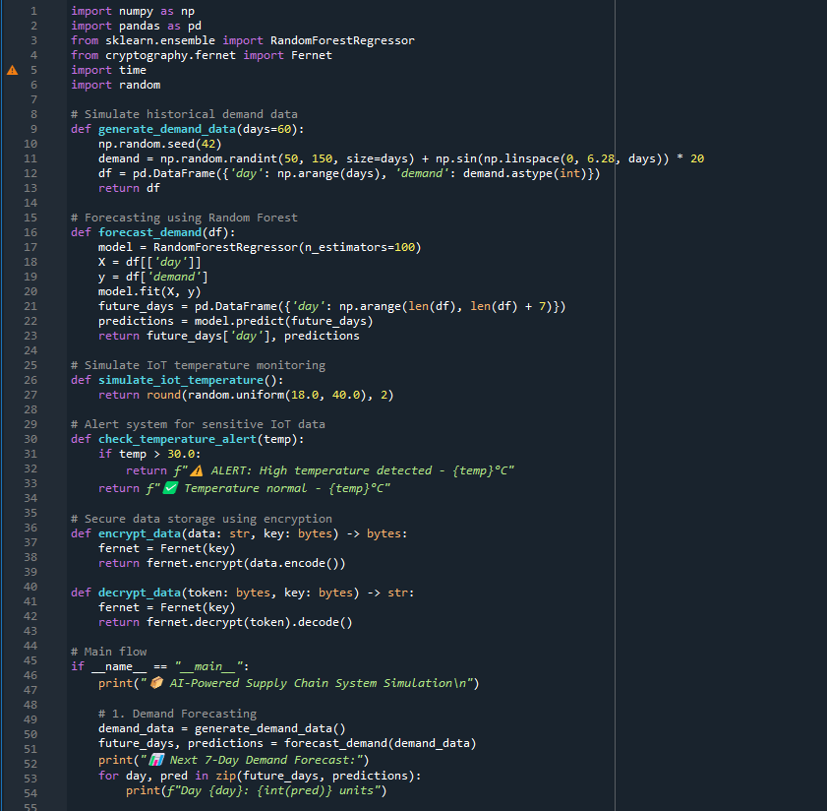

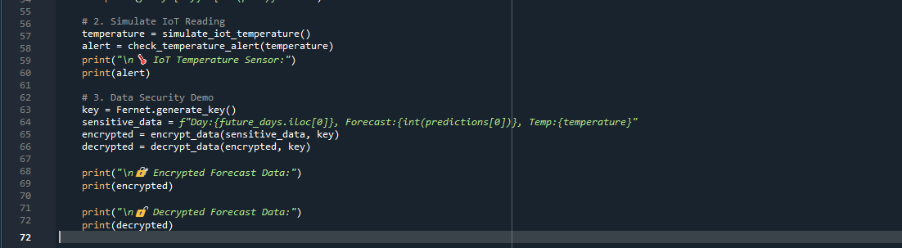

OUTPUT:

